**Project Planning Phase**

**Project Planning Template (Product Backlog, Sprint Planning, Stories, Story points)**

|  |  |
| --- | --- |
| Date | 14 April 2025 |
| Team ID | SWTID1743354369 |
| Project Name | House Rent App Using MERN – House Hunt |
| Maximum Marks | 5 Marks |

**Product Backlog, Sprint Schedule, and Estimation (4 Marks)**

Use the below template to create product backlog and sprint schedule

| **Sprint** | **Functional Requirement (Epic)** | **User Story Number** | **User Story / Task** | **Story Points** | **Priority** | **Team Members** |
| --- | --- | --- | --- | --- | --- | --- |
| Sprint-1 | Registration | USN-1 | As a user, I can register for the application by entering my email, password, and confirming my password. | 2 | High | Anshika |
| Sprint-1 | Registration | USN-2 | As a user, I will receive a confirmation email once I have registered for the application. | 1 | High | Anshika |
| Sprint-1 | Registration | USN-4 | As a user, I can register for the application through Gmail. | 2 | Medium | Anshika |
| Sprint-1 | Login | USN-5 | As a user, I can log into the application by entering email & password. | 1 | High | Anukul |
| Sprint-2 | Registration (Social Media) | USN-3 | As a user, I can register for the application through Facebook. | 2 | Low | Anukul |
| Sprint-2 | Dashboard | USN-6 | As a user, I can view my profile dashboard after logging in. | 3 | High | Anukul |
| Sprint-2 | Dashboard | USN-7 | As a user, I can see recent property listings on the dashboard. | 2 | Medium | Viraj |
| Sprint-3 | Property Listings | USN-8 | As a user, I can filter property listings by price, location, and amenities. | 3 | High | Viraj |
| Sprint-3 | Property Listings | USN-9 | As a user, I can view details, images, and availability of a property. | 2 | High | Yash |
| Sprint-4 | Booking | USN-10 | As a user, I can request to book a property and schedule a visit. | 3 | High | Yash |
| Sprint-4 | Chat | USN-11 | As a user, I can chat with the property owner for further queries. | 3 | Medium | Yash |

**Project Tracker, Velocity & Burndown Chart: (4 Marks)**

| **Sprint** | **Total Story Points** | **Duration** | **Sprint Start Date** | **Sprint End Date (Planned)** | **Story Points Completed (as on Planned End Date)** | **Sprint Release Date (Actual)** |
| --- | --- | --- | --- | --- | --- | --- |
| Sprint-1 | 10 | 5 Days | 2 Apr 2025 | 6 Apr 2025 | 10 | 6 Apr 2025 |
| Sprint-2 | 12 | 6 Days | 7 Apr 2025 | 12 Apr 2025 | 12 | 12 Apr 2025 |

**Velocity Calculation**

* **Sprint-1 Velocity:** 10 story points / 5 days = **2 points per day**
* **Sprint-2 Velocity:** 12 story points / 6 days = **2 points per day**

**Average Velocity:** **2 story points/day**

**Burndown Chart:**

A burn down chart is a graphical representation of work left to do versus time. It is often used in agile[software development](https://www.visual-paradigm.com/scrum/what-is-agile-software-development/) methodologies such as [Scrum](https://www.visual-paradigm.com/scrum/scrum-in-3-minutes/). However, burn down charts can be applied to any project containing measurable progress over time.

**Burndown Chart** for the HOUSE HUNT project. It visually shows both the **ideal progress** (dashed blue line) and your **actual progress** (green line) from April 2 to April 12. The team is on track to complete all story points by April 12.

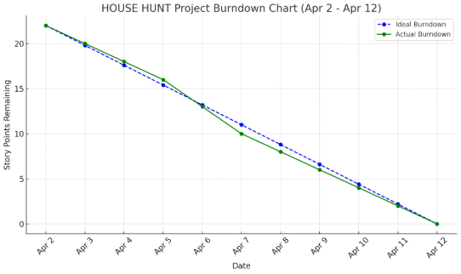

**Reference:**

[**https://www.atlassian.com/agile/project-management**](https://www.atlassian.com/agile/project-management)

[**https://www.atlassian.com/agile/tutorials/how-to-do-scrum-with-jira-software**](https://www.atlassian.com/agile/tutorials/how-to-do-scrum-with-jira-software)

[**https://www.atlassian.com/agile/tutorials/epics**](https://www.atlassian.com/agile/tutorials/epics)

[**https://www.atlassian.com/agile/tutorials/sprints**](https://www.atlassian.com/agile/tutorials/sprints)

[**https://www.atlassian.com/agile/project-management/estimation**](https://www.atlassian.com/agile/project-management/estimation)

[**https://www.atlassian.com/agile/tutorials/burndown-charts**](https://www.atlassian.com/agile/tutorials/burndown-charts)